The Islamia University of Bahawalpur
Department of Information Technology



Smart Resume
Submitted by Muhammad Fahemm Yousaf
Registration No: S23BINFT1E02056
Submitted to Mam. Sara Freed
Department of Information Technology
Faculty of Computing
The Islamia University of Bahawalpur

1.1 Scope of the Project
The scope of the Smart Resume Project is to provide an automated, web-based recruitment assistance platform that reduces the gap between job seekers and employers. The project aims to replace the traditional manual hiring process with a data-driven, intelligent solution that ensures faster and more relevant job matching.
This system focuses on three major aspects:
• Resume Analysis–Reading and extracting meaningful data (skills, education, and job category) from uploaded resumes.
• Job Posting–Providing an interface for companies to post vacancies dynamically.
• Recommendation Engine – Matching candidates with the most suitable jobs using category and skill matching.
The project scope is carefully defined to ensure that it remains achievable within the given timeframe of a final year project, while still delivering a practical, working solution.
1.1.1 Resume Upload
Job seekers can upload their resumes in DOCX or PDF format. These are the two most widely used resume formats and are supported by the system to maximize usability. Uploaded files are securely stored in the server for processing.
1.1.2 Resume Parsing (PDF/DOCX)
The system uses open-source libraries such as smalot/pdfparser for PDF files and phpoffice/phpword for Word files. These libraries convert resumes into plain text, which becomes the input for the analysis engine.
1.1.3 Skill Extraction
The extracted text is scanned for keywords and technical skills. For example, if the resume contains words like Java, HTML, Database Management, the system stores these as structured skill entries in the database.

11

1.1.4 Category Identification
Every resume is assigned to a main category (such as Engineering, Finance & Business Education, Sales & Marketing, Health and IT & Networking). This step ensures that job recommendations remain relevant and that a candidate is not shown jobs outside their field of expertise.
1.1.5 Job Posting System
Recruiters and companies can post job opportunities by filling out a form. They must enter job title, required category, required skills, and description. The posting is instantly saved in the jobs table of the database.
1.1.6 Job Recommendation System
The recommendation system applies a two-stage filtering process:
• Category Matching–The system first matches the resume category with job category.
• Skill Matching–Then it compares candidate skills with job requirements. Only those jobs which pass both filters are recommended to the candidate.
1.1.7 Dynamic Job Display
In the Smart Resume system, whenever a recruiter posts a new job, the job details is immediately stored in the jobs database. These postings are not shown blindly on the main page to all visitors. Instead, the jobs are only recommended to users after they upload and analyze their resumes.
The recommendation engine checks the category of the resume and compares it with the category of available jobs. If both categories match and at least one skill overlap, the job is displayed to that specific user on the recommendation results page.
1.1.8 User Experience:
The Smart Resume system has been designed with a strong focus on user experience (UX). The platform is responsive, meaning it adapts smoothly to desktops, laptops, tablets, and mobile devices.

12

• Simplicity: The interface is kept clean and user-friendly so that both job seekers and recruiters can easily interact with the system without technical knowledge.
• Resume Upload: A straightforward upload form enables candidates to analyze their resumes with just a few clicks.
• Job Posting: Recruiters can quickly post jobs using a guided form with necessary fields such as title, category, skills, and description.
• Recommendation Results: After analysis, candidates are shown relevant job recommendations in a clear and organized manner.
• Performance: Pages load quickly, and the system responds in real-time to provide a seamless experience.

1.1.9 Database Management
The backbone of the Smart Resume system is its relational database, implemented using MySQL. The database ensures that resume uploads, analysis results, and job postings are stored in a structured and consistent way for efficient processing and retrieval.
Key aspects of database management include:
• Data Storage:
Uploaded resumes are stored in the resumes table. Resume analysis results such as extracted skills, assigned category, and overall score are stored in a dedicated
• Resume analysis table, which maintains a one-to-one relationship with the resumes
table. Job postings are stored in the jobs table, which contains job title, category, required skills, description, and location.
• Dynamic Processing
Resume analysis is performed by the system after upload, and job recommendations are generated dynamically at runtime by matching resume analysis results with available job
postings. Recommendation results are displayed to users and are not stored permanently in the database in the current version of the system.
• Efficiency
The database structure is designed to minimize redundancy and improve query performance, making it suitable for an academic prototype.

13

• Scalability
The schema allows future extensions such as user authentication, advanced resume analysis techniques and persistent recommendation storage without requiring major restructuring.
• Security
Basic validation and controlled data handling mechanisms are applied to ensure secure storage and processing of resume files and job-related data.
1.2 Objectives of the Project

The primary objective of the Smart Resume project is to develop an intelligent, web-based system that automates resume analysis and provides relevant job recommendations to job seekers while simplifying job posting for recruiters.
The specific objectives of the project are as follows:
• To design a system that allows users to upload resumes in PDF and DOCX formats.
• Too automatically parse resumes and extract key information such as skills and experience.
• To classify resumes into appropriate job categories for accurate matching.
• To analyze resume quality and generate an overall score along with improvement suggestions.
• To provide recruiters with an interface to post job opportunities dynamically.
• To recommend suitable jobs to users based on category and skill matching logic.
• To ensure real-time job recommendations without storing recommendation history.
• To build a user-friendly, responsive interface for both job seekers and recruiters.

14

2.1 Main Aim
The main aim of the Smart Resume system is to provide an automated, intelligent, and web- based recruitment assistance platform that reduces the gap between job seekers and recruiters. In traditional recruitment systems, employers manually review a large number of resumes, which is time-consuming, error-prone, and inefficient. Similarly, job seekers often struggle to identify suitable opportunities that match their skills and qualifications.
The Smart Resume system solves these problems by:
• Automating the process of resume parsing and skill extraction.
• Classifying candidates into appropriate job categories.
• Providing recruiters with an easy-to-use job posting system.
• Delivering accurate and relevant job recommendations to job seekers.
By achieving these aims, the system significantly reduces the workload of recruiters and improves the chances of job seekers finding suitable employment opportunities.
2.2 Future Prospects
The Smart Resume project has been designed with scalability and future expansion in mind. While the current system focuses on parsing resumes, categorizing them, and recommending jobs, several future enhancements can be added:
• Machine Learning Integration–Using advanced machine learning models to improve skill extraction and job matching accuracy.
• Natural Language Processing (NLP) – Implementing NLP techniques for better understanding of unstructured resume text.
• Employer Dashboard – Providing recruiters with insights such as the number of matched candidates and skill gaps in applicants.
• Candidate Profile Management – Allowing candidates to create profiles, track applications, and update resumes.
• Advanced Search & Filters–Enabling recruiters to search resumes by keyword, skills,
or categories.

16

• Mobile Application – Developing a mobile app version of the platform for better accessibility.
• AI-Powered Recommendations–Offering smart suggestions to candidates about how they can improve their resumes for better job matches.
These prospects highlight the potential of Smart Resume to evolve into a complete recruitment management system in the future.
2.3 Features of software
The Smart Resume system offers several key features that make it unique and useful:
• Resume Upload–Users can upload resumes in PDF or DOCX format.
• Resume Parsing–Extracts text data from uploaded resumes using parsing libraries.
• Skill Extraction–Automatically identifies technical and professional skills from the resume text.
• Category Identification–Classifies each resume into a suitable job category such as IT, Engineering, or Business.
• Job Posting Module–Recruiters can post jobs by filling out a form that includes job title, required category, skills, and description.
• Job Recommendation Engine–Matches resumes with relevant jobs using category and skill matching.
• Dynamic Recommendations – New jobs are instantly considered during the recommendation process without needing system updates.
• Database Management–Stores all resumes, job postings, and analysis results in a structured MySQL database.
• User-Friendly Interface–Simple, responsive, and intuitive interface designed using Tailwind CSS for a smooth user experience.
• Scalability–The system design allows easy integration of advanced features such as AI models, dashboards, and mobile applications in the future.
• Exporting Suggestions as PDF–The system provides an “Export Suggestions as PDF” button that lets users download their improvement suggestions as a PDF for easy saving and sharing.

17

3.1 Introduction
System design is a crucial phase of software development, as it transforms the requirements
gathered during analysis into a structured blueprint for implementation. In the Smart Resume project, system design plays a key role in ensuring that the processes of resume parsing, skill extraction, category identification, and job recommendation are efficiently executed.
The Smart Resume system design is divided into two parts:
• Logical Design–Focuses on the flow of data, functional requirements, and interactions between different modules (e.g., resume upload, parsing, job posting, recommendation).
• Physical Design–Defines how the system will be implemented, including database schema, user interface design, and integration of backend and frontend components.
The primary goal of the system design is to ensure that the application is scalable, reliable, and easy to use for both candidates and recruiters.

3.2 Software design
Software design is the process of describing how different modules of the Smart Resume system will work together to achieve the desired functionality. The purpose of this design is to ensure that the system is well-structured, scalable, and easy to maintain. The Smart Resume project uses UML diagrams and data modeling techniques to clearly represent the interactions between users and the system.
3.2.1 Visual modeling using UML
Unified Modeling Language (UML) is a standardized modeling language that is widely used in software engineering to visualize, design, and document software systems. It provides a set of
graphical notations and diagrams that help developers and stakeholders understand the system’s
structure and behavior before actual coding begins.
In the Smart Resume System, UML is used as a blueprint to represent the interaction between different modules of the system such as Resume Upload, Resume Analysis, Job Posting, and the Job Recommendation process. By using UML diagrams, the system design becomes more understandable, maintainable, and reduces the chances of errors during implementation.

19

Advantages of UML in this project
• Visualization: Complex processes like resume parsing, job recommendation, and database interaction are represented clearly.
• Communication: UML diagrams serve as a common language between developers, supervisors, and evaluators.
• Error Reduction: Potential design issues can be identified and corrected before coding.
• Maintainability: Modular design ensures that future improvements (such as advanced analysis techniques or AI-based enhancements) can be integrated easily.
UML Diagrams used in Smart Resume System
• Use Case Diagram: Shows interaction between Job Seekers and Recruiters with the Smart Resume System.
• Sequence Diagram: Represents the step-by-step flow of resume upload, analysis, and job recommendation.
• Collaboration Diagram: Illustrates interactions between system components during the job recommendation process.
• E-R Diagram: Represents database tables and their relationships.

3.2.2 System Workflow
The Smart Resume system follows a structured workflow to connect job seekers and recruiters:
Resume Upload and Analysis
The user selects the Upload Resume option from the homepage.
The system opens the computer’s file explorer where the user selects a resume in PDF/DOCX
format.
After clicking Analyze Resume, the system parses the document and extracts skills, education, and category.

20

The candidate is then shown the Overall Score, Suggestions for Improvement, Actionable Steps, and Extracted Skills.

1. Job Posting (Recruiter Side)
• Recruiters or business owners use the Add Job form to post vacancies.
• The job details (title, category, required skills, description, location) are stored in the database.
2. Job Recommendation
• The recommendation engine compares the candidate’s category and skills with the jobs in the database.
• If a match is found, the relevant jobs are displayed in the Recommended Jobs section.
• If no match is found, the system displays the message:
No job recommendations available for your category at the moment.
3.2.3 Use Case Diagram
A Use Case Diagram is a behavioral UML diagram that represents the interaction between actors (users) and the system. It provides a high-level view of what the system does from the perspective of its end users.
In the Smart Resume Project, the use case diagram illustrates how Job Seekers, Recruiters, and the System interact with each other.
Actors in the System
• Job Seeker: Upload resume, view recommended jobs.
• Recruiter: Post new jobs, manage job postings.
• System (Smart Resume): Parse resumes, extract skills, match jobs, and provide recommendations.

21

Major Use Cases
• Upload Resume–Job seeker uploads resume in PDF/DOCX format.
• Parse Resume–System extracts text, identifies skills, and assigns a category.
• Post Job–Recruiters post jobs by entering job details and requirements.
• Recommend Jobs–The system recommends jobs by comparing candidate’s skills with
job requirements.
• View Recommended Jobs–Candidate views the list of matched jobs.
Explanation
The Job Seeker interacts with the system to upload a resume and receive job recommendations. The Recruiter interacts with the system to add jobs into the database.
The System acts as the central controller, parsing resumes and generating recommendations.

3.2.3 Use Case Diagram of Job Seeker

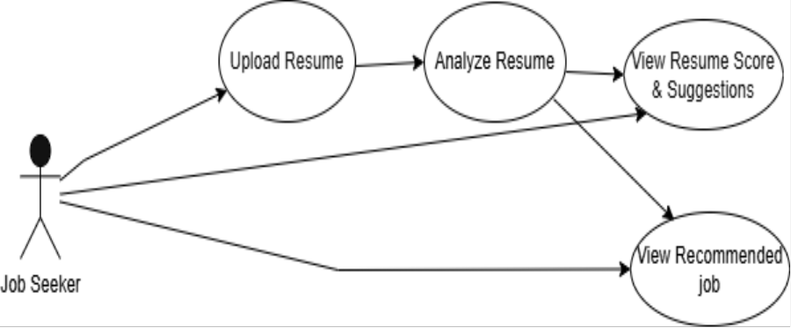

22

3.2.3 Use Case Diagram of Job Recruiter

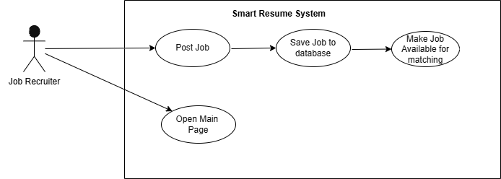

3.2.4 Sequence diagram
A Sequence Diagram shows the step-by-step interaction between the user and the system over time. In the Smart Resume project, this diagram represents how a Job Seeker uploads a resume and how the system processes it to generate job recommendations.
Actors and Components
• Job Seeker
• Resume Upload Module
• Parser
• Skill Extractor
• Recommendation Engine
• Database
• Recommendation Page
The diagram below shows how the request flows from uploading the resume to viewing the recommended jobs.

23

3.2.4 Sequence Diagram of Job Seeker and System

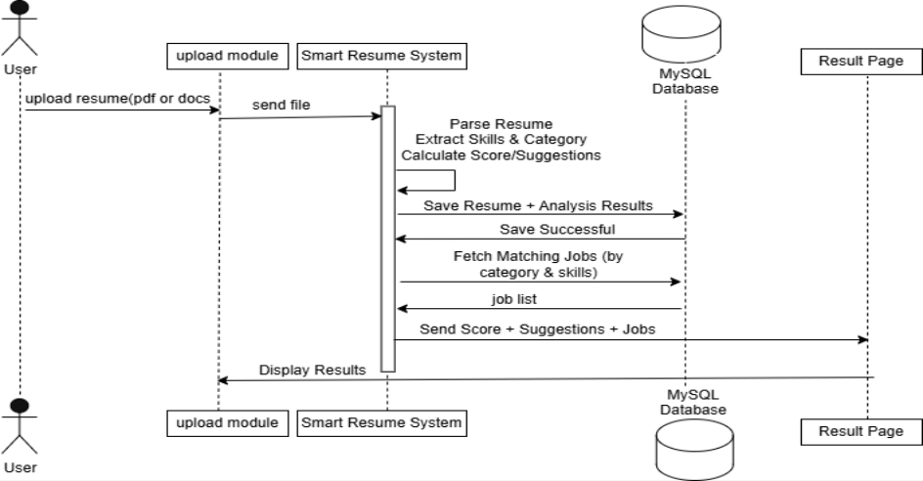

3.2.5 Collaboration Diagram
A Collaboration Diagram shows how different system components interact with each other by passing messages. It focuses on the relationships between objects instead of time. In the Smart Resume Project, the Job Seeker uploads a resume; the system parses it, extracts skills, checks the database for matching jobs, and finally displays recommended jobs back to the user.

24

3.2.5 Collaboration Diagram of Job Seeker and System

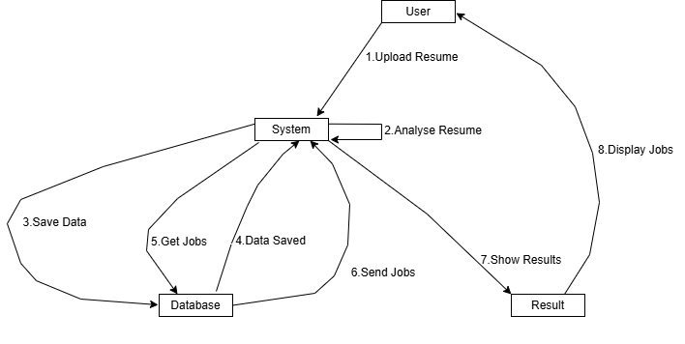

3.2.6–E-R Diagram
An Entity-Relationship (E-R) Diagram is used to describe the logical structure of the database. It defines the main entities, their attributes, and the relationships among them. In the Smart Resume System, the E-R diagram represents how resume data, analysis results, and job postings are
organized in the database.
Main Entities
• Resume: Stores uploaded resume files along with file name, file path, extracted text, and upload time.
• Resume Analysis: Stores analysis results such as extracted skills, assigned category,
overall score, and suggestion data generated after resume parsing.
• Job: Represents job postings created by recruiters, including job title, category, required skills, description, and location.

Relationships
• Each Resume is associated with one Resume Analysis record.
• Resume Analysis results are used to dynamically match relevant Jobs based on category and skill matching logic.
• Job recommendations are generated dynamically and are not stored as a separate database table.
25

3.2.6 ER Diagram

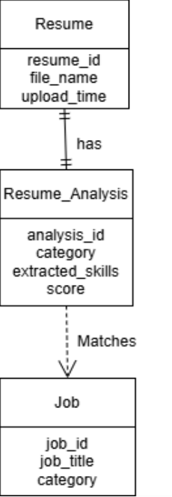

26

4.1 Software Development Approach
Software Development
The development of the Smart Resume System was carried out following a structured approach to ensure accuracy, efficiency, and maintainability. The project was developed as a web-based application using a modular design, where each component (resume uploader, parser, analysis engine, job recommendation system) was built and tested independently before integration.
The development followed an incremental model, meaning the system was created in small modules and improved step by step. First, the resume upload and parsing features were implemented, then skill extraction and job posting modules were added, and finally the recommendation engine was integrated with the database.
Key considerations during development included:
• Scalability – Designing the system so that new features can be added without restructuring.
• Security–Ensuring resume files and user data are safely stored in the database.
• Efficiency–Optimizing parsing and recommendation processes for faster results.
• Usability– Keeping the interface simple and easy to use for both job seekers and recruiters.
4.2 Tool selection
The development of the Smart Resume System required a combination of programming languages, frameworks, and tools. Each tool was selected based on project requirements such as web development, database management, and resume parsing.
4.2.1 Visual Studio Code
Visual Studio Code was used as the primary Integrated Development Environment (IDE). It was chosen because of its lightweight design, support for multiple programming languages,
built-in debugging tools, and availability of extensions for PHP, MySQL, and JavaScript. This made the coding process faster and more efficient.

28

4.2.2 XAMPP / PHP MyAdmin
For backend development and database connectivity, XAMPP was used as a local server environment. It provides Apache, PHP, and MySQL support in a single package. PHP MyAdmin, included in XAMPP, allowed easy management of the MySQL database using a graphical interface.
4.2.3 MySQL
MySQL was selected as the relational database for the system. It is widely used, open-source, and supports advanced querying. It stores user details, resumes, extracted skills, job postings, and recommendations in a structured format. The database was normalized to Third Normal Form (3NF) to ensure consistency and reduce redundancy.
4.2.4 PHP and Supporting Libraries
PHP was used as the main server-side scripting language to handle resume uploads, parsing integration, and communication with the database.
Smalot/pdfparser was used for extracting text from PDF resumes. PhpOffice/phpword was used for parsing Word (.docx) resumes.
These libraries provided accurate text extraction for further analysis.
4.3 Hardware for the System
The Smart Resume System was designed as a lightweight web-based application that can run on any standard computing environment. Both development and testing were carried out on commonly available hardware and operating systems to ensure accessibility.
4.3.1 Operating Systems
The system is compatible with multiple operating systems, including:
• Windows 10/11 (used during development)
• Linux distributions (e.g., Ubuntu)
• macOS (with PHP and MySQL support)
This flexibility ensures that the system can be deployed across different environments.

29

4.3.2 Supported Architectures
The application is developed to support standard 32-bit and architectures, ensuring compatibility with modern computing devices.
4.3.3 Hardware Requirements
The minimum and recommended hardware requirements are as follows:
• Processor: Intel Core i3 or higher (Recommended: i5 or above)
• RAM: Minimum 4 GB (Recommended: 8 GB or higher for faster processing)
• Storage: At least 1 GB free space for project files and database (Recommended: SSD for faster query execution)
• Internet Connectivity: Required for uploading resumes and accessing dynamic job postings.

30

5.1 Implementation
The implementation phase of the Smart Resume System focused on integrating all designed modules and ensuring smooth functionality. The project was implemented as a web-based platform where job seekers can upload their resumes, the system analyzes them, and recruiters can post jobs dynamically.
The key steps in implementation were:
1. Frontend Development:
• Designed using HTML, CSS, and JavaScript for responsive web pages.
• User-friendly forms for resume upload and job posting were created.
2. Backend Development:
• Implemented in PHP to handle resume uploads, parsing, and communication with the database.
• Libraries like Smalot/pdfparser and PhpOffice/phpword were integrated for extracting text from resumes.
3. Database Integration:
The MySQL database stores resumes, resume analysis results, and job postings in a structured manner. Resume analysis data is maintained in a separate resume_analysis table, while job postings are stored in the jobs table. Job recommendations are generated dynamically at runtime based on category and skill matching logic and are not stored permanently in the database.
• Data was normalized to reduce redundancy and improve performance.
4. Recommendation Engine:
• Implemented logic for Category Matching and Skill Matching.
• Ensured that only relevant jobs are recommended to users.
5. Testing & Debugging:
• Each module was tested independently before integration.
• Errors and mismatches during parsing and recommendation were fixed iteratively. Through proper implementation, the Smart Resume System successfully transformed into a
working prototype that demonstrates the feasibility of an AI-assisted recruitment system
32

5.2 Agile Software Development
The Smart Resume System was developed using the Agile Software Development methodology. Agile was chosen because it allows development in small, incremental steps, ensuring flexibility, continuous testing, and quick adaptation to changes in requirements.
Instead of building the entire system at once, the project was divided into iterations (sprints). In each sprint, a specific module (e.g., resume upload, parsing, recommendation engine) was developed, tested, and integrated. This iterative cycle helped in minimizing errors and achieving faster results.
5.2.1 User Concerns
During development, special attention was given to user expectations and usability, such as:
• Ease of Use: Job seekers should be able to upload resumes and get results quickly.
• Accuracy: Skills and categories extracted from resumes must be correct to improve job matching.
• Privacy: Uploaded resumes and personal details must be kept secure in the database.
• Relevance: Job recommendations must match the candidate’s skills and category.
5.2.2 Designer Concerns
From the developer’s perspective, the system was implemented keeping the following concerns in mind:
• Modularity: Each component (parser, database, recommendation engine) was developed separately for easy debugging.
• Scalability: The database design and backend logic were made flexible so that new features can be added in the future.
• Performance: Queries and parsing operations were optimized for speed.
• Maintainability: The code was written in a clean and structured way so that future developers can easily update it.

33

5.3 Testing
Testing is a critical phase of software development that ensures the system functions correctly and meets user requirements. In the Smart Resume System, different testing methods were applied at various stages to verify correctness, detect bugs, and validate performance.
5.3.1 Unit Testing
Unit testing was performed on individual modules, such as:
• Resume Upload Module: Verified that PDF and DOCX files are uploaded and stored correctly.
• Parser Module: Ensured text extraction from resumes was accurate.
• Skill Extractor: Checked whether relevant skills and categories were correctly identified.
Each unit was tested in isolation before being integrated into the system.
5.3.2 Integration Testing
After unit testing, modules were combined and tested as a group For example:
• Resume Upload→Parsing→Skill Extraction→Database Storage.
• Job Posting → Database → Recommendation Engine → Recommendation Page.
This ensured smooth interaction between different modules and identified errors in data flow.
5.3.3 Database Testing
Since the project heavily relies on a MySQL database, database testing was essential. Tests included:
• Schema Validation: Ensured foreign key relationships were correct.
• Data Integrity: Verified that user, resume, and job data was stored without redundancy.
• Query Performance: Checked that recommendation queries returned results quickly.
• Security: Tested protection against SQL injection and unauthorized access.

34

5.4 Acceptance, Installation, Deployment
Once development and testing were completed, the Smart Resume System went through the acceptance and deployment phase to ensure that it was ready for real-world use.
5.4.1 Acceptance
Acceptance testing was carried out with the help of end-users (job seekers and recruiters). The main goals were:
• To confirm that resume uploads, parsing, and recommendations worked as expected.
• To validate that the job postings and recommendations were relevant and accurate.
• To check the usability and user interface design.
5.4.2 Installation
The installation process was simple, as the system was web-based. Key steps included:
• Installing XAMPP to set up Apache, PHP, and MySQL.
• Importing the MySQL database schema and configuring tables.
• Deploying the PHP source code in the htdocs folder.
• Verifying that the system could run on any standard browser without additional software.
5.4.3 Deployment
The system was deployed in a local environment for demonstration and evaluation. Deployment steps included:
• Hosting the application on a local server (localhost).
• Ensuring database connectivity with PHPMyAdmin.
• Allowing multiple users (students/faculty) to access the system within the college network.
5.5 System Maintenance
The Smart Resume System requires regular maintenance to ensure smooth performance and long-term usability. Since it is a web-based application, maintenance includes fixing issues, updating features, and securing user data.

35

Types of Maintenance
• Corrective Maintenance: Fixing bugs or errors in resume upload, parsing, or job recommendations.
• Adaptive Maintenance: Updating the system for compatibility with new versions of PHP, MySQL, or browsers.
• Perfective Maintenance: Improving system features such as recommendation accuracy and user interface.
• Preventive Maintenance: Regular database backups, query optimization, and applying security patches.
With proper maintenance, the system remains reliable, secure, and ready for future enhancements.
Security Considerations
The system includes essential security measures such as file type validation and controlled data handling to prevent invalid uploads. Since this is an academic prototype, it uses basic protection instead of enterprise-level security features. These measures are sufficient for project demonstration and ensure safe processing of resume files and job data.

36

6.1 Main Page
The Main Page serves as the entry point of the Smart Resume system.
• It provides a simple and user-friendly interface with a drag & drop area and a Browse
option for uploading resumes.
• Users can directly click on the “Analyze My Resume” button to start the resume evaluation process.
• Navigation links (Features, How It Works, FAQ, Add job) are included to enhance the user experience.

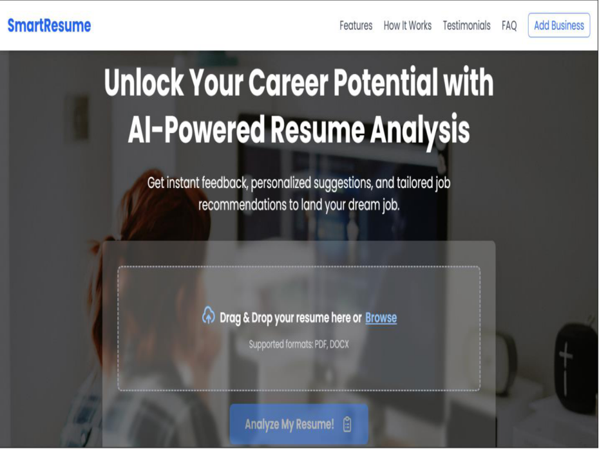

38

6.2 Resume Upload Page
When the user clicks the Resume Upload button, the system directly opens the computer’s file explorer.
• The user selects their CV in PDF or DOCX format.
• Once the file is selected, the system validates it and waits for the user to click Analyze.
• Unsupported file formats are rejected to ensure consistency.

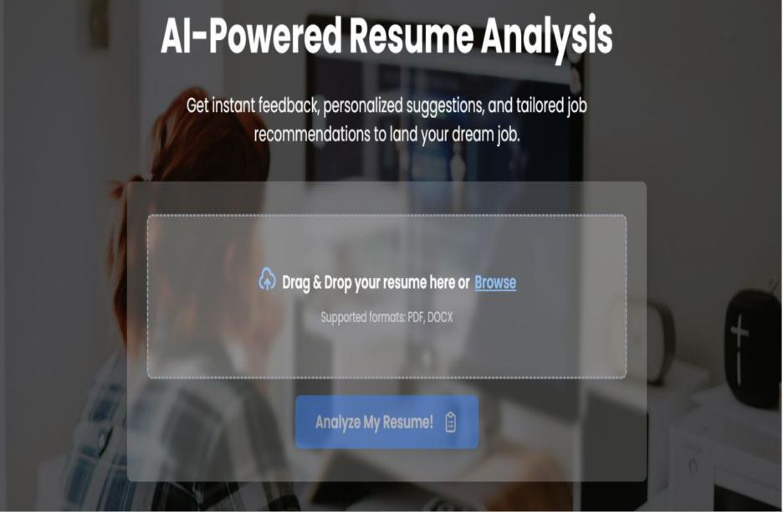

39

6.3 Job Posting Page (Recruiter Side)
The Job Posting Page allows recruiters to post new job opportunities.
• The form includes fields such as: Job Title, Company Name, Category, Location, Required Skills, and Job Description.
• Upon clicking the Post Job button, the job details are saved into the system’s database.
• Recruiters immediately receive a success message if the posting is successful or an error message in case of invalid data.

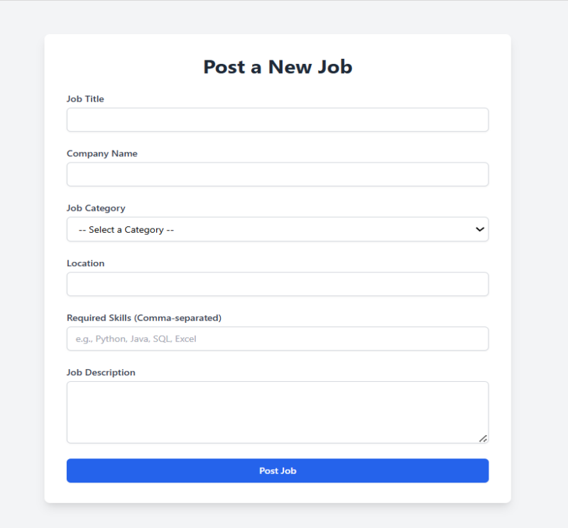

40

6.4 Resume Analysis & Suggestions Page

After uploading the resume, the system displays the Resume Analysis & Suggestions Page. This page shows the Overall Score (0–100) which reflects the completeness and quality of the resume
based on key sections such as skills, experience, and education.
The system also provides Suggestions for Improvement along with Actionable Steps to help users enhance their resume quality. An Export Suggestions as PDF button is available, allowing users to download the improvement report for future use.

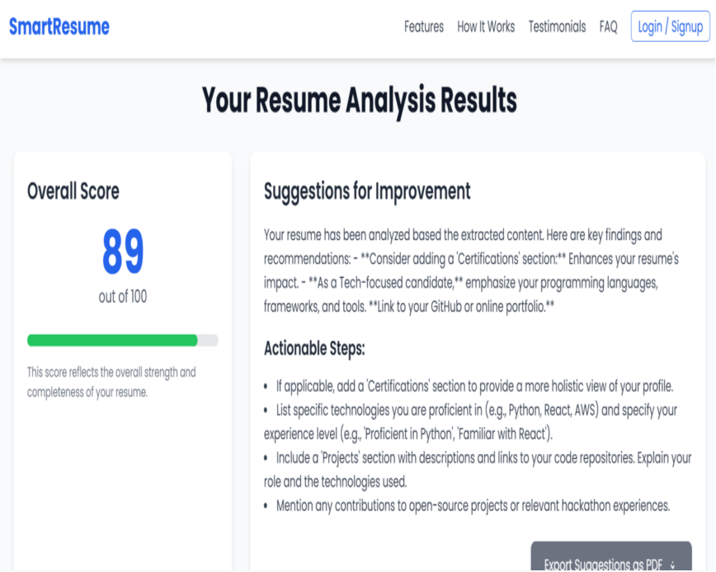

6.5 Skill Analysis & Graphical View

To provide better visual understanding, the Smart Resume systems present graphical analysis of skills and resume sections. A Skill Proficiency Bar Chart shows the strength of detected skills,
41

while a Section Completion Donut Chart highlights which resume sections are complete or missing.
These visual representations help users quickly identify weak areas and focus on improving their resume effectively.

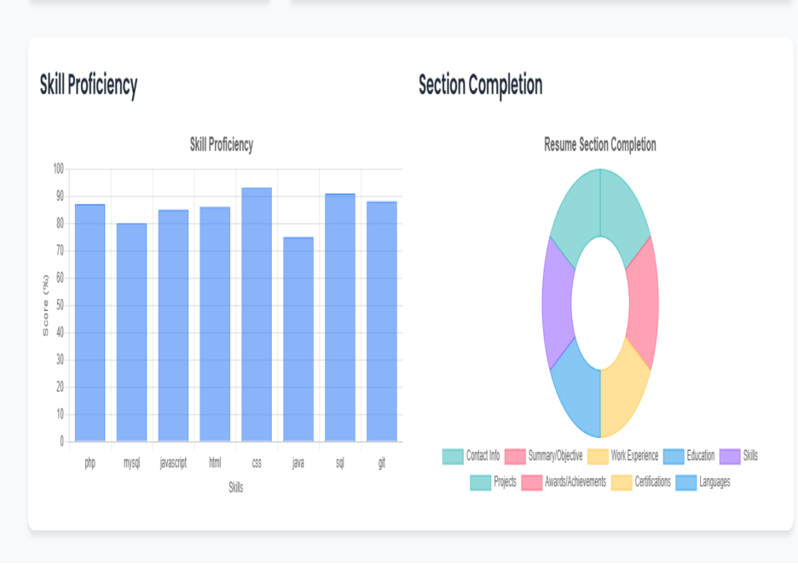

6.6 Job Recommendation Page

42

After resume analysis, the system displays the Job Recommendation Page. This page shows a list
of recommended jobs fetched dynamically from the database based on category matching and skill matching.
Only those jobs are displayed whose required skills and category align with the user’s resume. The recommendations are generated in real time, ensuring that users always see the most relevant and active job opportunities.

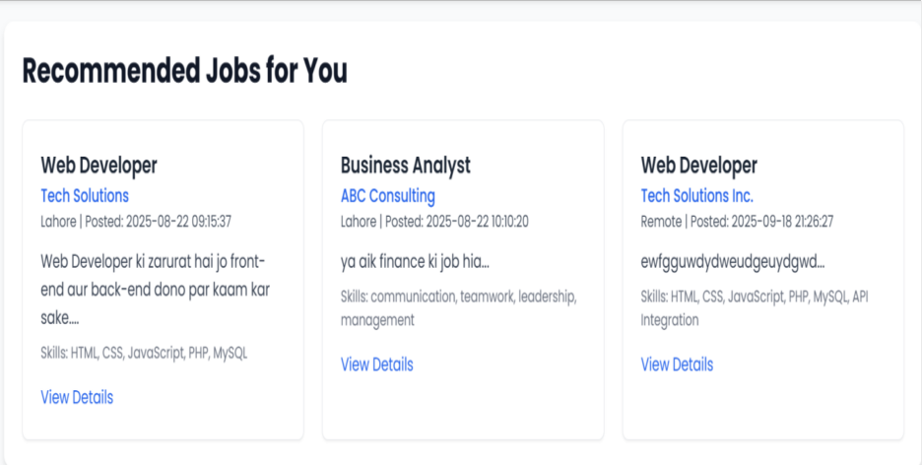

43

The Smart Resume System successfully demonstrates the development of an AI-assisted recruitment platform designed to bridge the gap between job seekers and employers. The project achieved its primary objectives by providing a streamlined and automated process for resume analysis, skill extraction, category identification, and real-time job recommendations.
Through its implementation, the system proved effective in:
• Reducing the manual effort required by recruiters to filter resumes.
• Providing candidates with personalized and actionable feedback to improve their resumes.
• Offering a responsive and user-friendly interface that ensures smooth interaction for both job seekers and recruiters.
The backend integration with PHP and MySQL, along with parsing libraries for PDF and DOCX files, validated the technical feasibility of the system. Additionally, the recommendation engine demonstrated how data-driven decision-making can enhance the efficiency and accuracy
of job matching.
While the system fulfills the requirements of a final-year project, it also provides strong potential for future expansion. Advanced features such as machine learning models, natural language processing (NLP), user authentication, and mobile app development can transform this prototype into a comprehensive recruitment management solution.
In conclusion, the Smart Resume project not only delivers on its promises but also opens the door to innovation in the recruitment process, offering significant value to both job seekers and employers.

References
1. PHP5 for Dummies
2. https://www.w3schools.com 3. https://www.php.net
45

